PAME I-2019: Agenda 9.2

Project Plan

Phase II: Marine Litter in the Arctic

Regional Action Plan on Marine Litter in the Arctic

(final draft version 7 Jan 2019)
Note: the content of this draft project proposal is subject to the content of the final agreed version of the ML Desktop Study.
The development of a Regional Action Plan (RAP) on Marine Litter in the Arctic builds upon the Phase I Project “[Draft] Desktop Study on Marine Litter including Micro-plastics in the Arctic (2019)”, which was based on best available science data and other information at the time of completion. The RAP may be updated in subsequent bienniums to address new and emerging information and priorities; therefore the structure needs to be realistic and adaptable. This project will address both sea and land-based activities, focusing on e.g., Arctic-specific marine litter sources and pathways, which will play an important role in demonstrating Arctic States’ stewardship efforts towards reducing the negative impacts of marine litter, including microplastics, to the Arctic marine environment.

Project Title:
Regional Action Plan on marine litter in the Arctic

Phase II (2019-2021):
- Develop a first version of a Regional Action Plan on marine litter in the Arctic based on the Desktop Study on Marine Litter (Phase I) and other resources and information, as relevant and specific to the Arctic.
- Collaborate with other Arctic Council working groups working on marine litter activities, such as AMAP’s work on monitoring, CAFF’s work on impacts of marine litter on wildlife, ACAP’s work on solid waste management, and others as relevant to marine litter in the Arctic to ensure that this work is adaquetly reflected in the first version of the Regional Action Plan.
- Continue the development of outreach and communication material.
- Develop an outline for possible activities during the 2021-2023 period based on progress and outcomes of Phase II.

Background
The universal challenge of addressing and managing marine litter is a useful illustration of the global and transboundary nature of many marine environmental problems, and marine litter is one of the most pervasive pollution problems affecting the marine environment globally. The United Nations Environment Programme (UNEP) defines marine litter as ‘any persistent, manufactured or processed solid material discarded, disposed of or abandoned in the marine and coastal environment’. Marine litter consists of items that have been made or used by people and deliberately discarded into the sea or rivers or on beaches; brought indirectly to the sea with rivers, sewage, storm water or winds; or accidentally lost, including material lost at sea in bad weather.
Arctic Council Ministers adopted the Regional Programme of Action for the Protection of the Arctic Marine Environment from Land-based Activities (Arctic RPA) in 1998 and updated it in 2009. The Arctic-RPA is a dynamic programme of action that uses a step-wise approach for its implementation and recognizes the continually evolving and dynamic situation in the Arctic environment and the need for an integrated and holistic approach. It is the regional extension of the Global Programme of Action for the Protection of the Marine Environment from Land-based Activities (GPA), and as such provides a framework for addressing the main pollution source categories and responding to the global concerns. Marine litter is one of eight contaminant categories of the GPA and the Arctic RPA. Other international organisations such as UNEP, the International Maritime Organisation, and Regional Sea Conventions such as OSPAR have instigated processes to combat marine litter.
The development of a RAP on Marine Litter in the Arctic builds upon the Phase I Project “[Draft] Desktop Study on Marine Litter including Micro-plastics in the Arctic (2019)” with the aim to provide information on the current status on this topic in the Arctic. (further information here). The [draft] Desktop Study lists a number of findings, gaps, and recommendations on next steps for PAME’s and other Arctic Council working groups’ considerations as relevant to their respective mandates.
It is envisioned that the RAP may be updated in subsequent bienniums to address new and emerging information and priorities, necessitating a realistic and flexible structure that remains adaptable. This project will address both sea and land-based activities, focusing on e.g., Arctic-specific marine litter sources and pathways, which will play an important role in demonstrating Arctic States’ stewardship efforts towards reducing negative impacts of marine litter, including microplastics, to the Arctic marine environment.

Objectives
The overarching objective is to develop a Regional Action Plan on Marine Litter addressing both sea and land-based activities, focusing on Arctic-specific marine litter sources and pathways. The flexible structure will allow for periodic updates, as appropriate, and incorporation of new and emerging information and priorities as identified through ongoing or novel studies by the Arctic Council, the Arctic States, and others.

Phase II Objectives (2019-2021):
- Develop a first version of a Regional Action Plan on marine litter in the Arctic reflecting findings, gaps, and recommendations of the Desktop Study on Marine Litter (Phase I).
- Consult and coordinate with other Arctic Council working groups as relevant in scoping out a Regional Action Plan on marine litter in the Arctic, in particular AMAP, which is developing a regional litter monitoring plan.
- Continue the development of outreach and communication material to enhance knowledge and awareness of marine litter in the Arctic.
- Engage with relevant stakeholders.
- Contribute to the prevention and/or reduction of marine litter in the Arctic and its impacts on marine organisms, habitats, public health and safety, and society.
In the long term, a Regional Action Plan on Marine Litter can assist Arctic States in meeting Sustainable Development Goal (SDG) 14, target 14.1: “by 2025, prevent and significantly reduce marine pollution of all kinds, in particular from land-based activities, including marine debris and nutrient pollution.”

Scope and Approach
This project will address both sea and land-based activities, focusing on e.g., Arctic-specific marine litter sources and pathways, which will play an important role in demonstrating Arctic States’ stewardship efforts towards reducing negative impacts of marine litter, including microplastics, to the Arctic marine environment. It is envisioned that the Regional Action Plan may be updated in subsequent bienniums, as appropriate, based on emerging information (e.g., ongoing or new studies by the Arctic Council, the Arctic States, and others, as relevant) and/or evolving priorities. Thus it is important that the Regional Action Plan be realistic, flexible, and structured in a manner that can easily be adapted to modify scope and content.
It may be necessary to revisit the scope and approach at a later stage as work proceeds.

Main activities during the 2019-2021 period:
- Develop a first version of a Regional Action Plan on marine litter in the Arctic:
- Initiate actions by taking stock of existing sources of information, including from the Desktop Study on Marine Litter (Phase I), national and regional efforts, other guidelines (e.g. UNEP Regional Seas Design Guide), as relevant.
- Consider the themes listed below for potential sections of the Action Plan as guidance in developing a stepwise approach in selecting action measures. It is preferable that actions be supported by scientific assessments on marine litter at the regional level to allow baselines to be set:
- Actions to reduce or eliminate sea-based sources of marine litter
- Actions to reduce or eliminate land-based sources of marine litter
- Removal Actions and Disposal
- Monitoring/Scientific Research
- Education and Outreach
- Consider criteria for setting priority actions such as:
  - Data and information in Phase I: Desktop Study on Marine Litter including Micro-plastics in the Arctic
  - Data gaps and research needs
  - Stakeholder input, as appropriate
  - Major sources and pathways of marine litter
  - Efforts and priorities of other Arctic Council Working Groups
- Take into account commonly accepted principles and approaches that provide justification for efforts to combat marine litter e.g. precautionary principle/approach, the polluter pays principle and ecosystem approach
- Education and Outreach : Develop a project video, on-line brochures, launch of the “plastic-in-bottle” project. An education package will be launched in August 2020, including an international litter competition, targeting students to increase awareness of marine litter and how to decrease the challenge with litter. (main responsibility: PAME, in close coordination with other AC working groups)
- Coordination and collaboration: with other Arctic Council working groups, working on marine litter activities, such as AMAP’s work on litter monitoring, CAFF’s work on impacts of marine litter on wildlife, ACAP’s work on solid waste management, and others as relevant to marine litter in the Arctic to ensure that this work is adaquetly refelected in the first version of the Regional Action Plan
The Development of a first version of the Regional Action Plan is an iterative process with formulation of detailed measures which may be revised or revisited during future phases of this work, or when further knowledge and information has been gained.

Timeline and Major Milestones (2019-2021):
In addition to the main activities, this phase will follow-up with activities from phase I, including outreach and communication. It is envisioned that the project will commence an expert group workshop to advance this work, in addition to meetings and teleconferences as needed.
Main tasks:
April 2019 | Arctic Council Ministerial – approval of PAME Work Plan
May 2019 | Re-establish a marine litter expert group with representatives from the Arctic Council working groups.
May 2019 | First teleconference to develop Terms of Refernce (ToR) for the expert group
June 2019 | Follow-up expert group teleconference
September 2019 | Presentation by project co-leads and discussions/inputs at PAME II-2019
2019 | Potential workshop/conference to advance the Regional Action Plan development (details to be provided and this may become a part of the proposed Plastic Conference plan by the Icelandic Arctic Council Chairmanship),
October 2019 | Presentation at the SAO meeting and guidance sought, as appropriate
February 2020 | Presentation by project co-leads and discussions/inputs at PAME II-2020
March 2020 | Presentation at the SAO meeting and guidance sought, as appropriate
August 2020 | Launch the Arctic marine litter education and competition package
September 2020 | Presentation by project co-leads and discussions/inputs at PAME II-2020
October 2020 | Presentation at the SAO meeting and guidance sought, as appropriate
February 2021 | Presentation by project co-leads and discussions/inputs at PAME II-2019
September 2021 | Presentation by project co-leads and discussions/inputs at PAME II-2019
March 2021 | Submission of an outline of a Regional Action Plan outline to SAOs for approval
Mars/Apr 2021 | Final layout and preparation for Ministerial
April 2021 | Arctic Council Ministerial

Overall estimated budget: Phase-II (2019-2021)
Consistent with the overall Arctic Council approach, the development of this project will be financed through voluntary contributions and in-kind support from member governments. The proposed stepwise approach, with PAME approval required for each phase, will facilitate financial planning and budgets. Financial contributions will be sought from other sources as well, such as the Nordic Council of Ministers and the Arctic Council Project Support Instrument (PSI).
Item | Budget (USD/in-kind)
Project management, coordination, consultation and outreach | 100.000
External expert(s) | 20.000
Workshop | 40.000
Editing, final layout and printing | 10.000
Arctic marine litter education and competition package | 50.000
Estimated total | 220.000

Project team Structure/Lead Countries
- Leads: Iceland, Norway, Sweden, Canada (tbc), USA, AIA, OSPAR, others?
- Each Arctic State government and Permanent Participants’ organization are invited to appoint a project team member for the projects advisory group, as well as participating at the Marine Litter Expert Group meetings twice a year.
- Collaboration with other Arctic Council working groups, as relevant, and other organizations e.g., OSPAR, PICES and ICES on the monitoring programme, and as relevant, from e.g., UNEP/GPA (GPML), as appropriate.
- The PAME Secretariat will provide administrative and project assistance.
- Other Arctic Council working groups will be consulted accordingly.

Annex: Communication and outreach activities
The communication and outreach activities will continue from the 2017-2019 period and include the following activities:
- Marine Litter workshop/conference
- Plastic in a bottle
- Project video
- Arctic marine litter competition
- Marine Litter graphics site on the PAME website for outreach purposes here

Marine litter workshop/conference
The advisory group will consult with the PAME HoDs on how best to contribute to the Plastic Conference planned during the Icelandic Chairmanship of the Arctic Council when further details have been provided.
Alternatively, or possibly in conjunction with such a conference, a project workshop/side event could be considered to be convened..

Plastic in a bottle
One aspect of PAME’s work on marine pollution is to set afloat up to five “plastics in a bottle” from across and around the Arctic. The specially designed capsules will be equipped with a GPS transmitter to illustrate how marine litter can travel, even between continents, contributing to the adverse effects of marine litter.
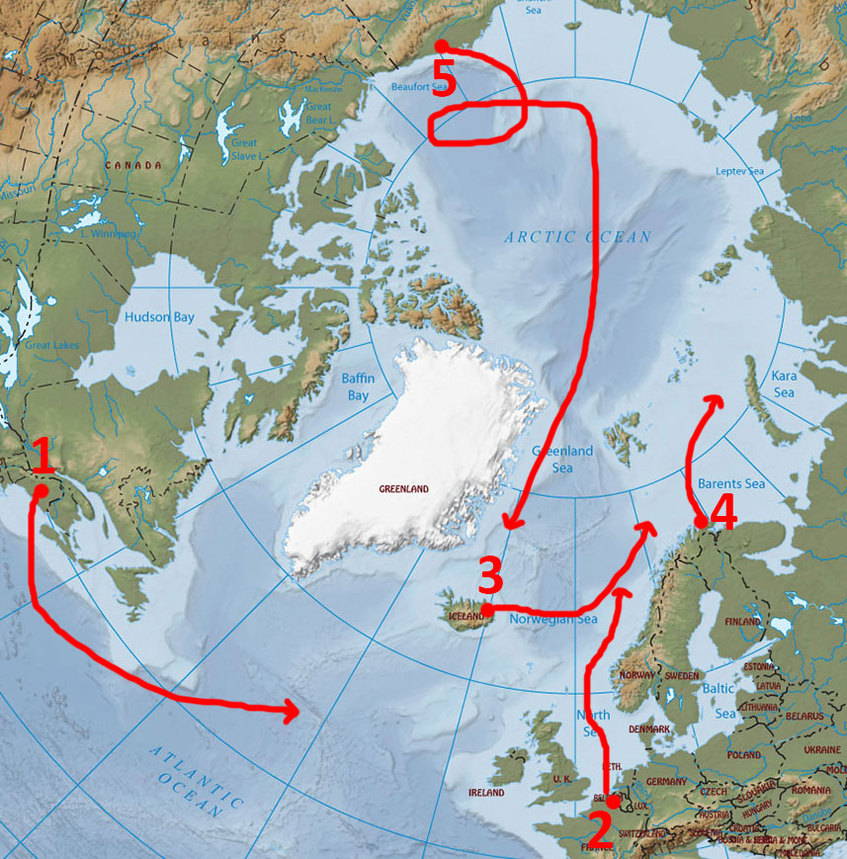
Note: A delay in the production of the transmitters from the manufacture has delayed this process significantly. The aim is to set the first capsules afloat in mid-2019.
Drift predictions of Plastic in a bottle
- Based on discussions with the Icelandic Meteorological Office and a leading expert in ocean currents.
Five areas have been identified as potential points to release the bottles, East Coast of USA (e.g. Maine), Netherlands, Iceland (east coast), Northern Norway and Alaska. These areas have been discussed with an expert on oceanography and meteorology (Dr. Halldór Björnsson) and a leading expert in Iceland on ocean currents (Dr. Steingrímur Jónsson).
Figure 1: Potential capsule drift.
According to them, one cannot expect an object like the plastic capsules to travel to certain areas with ocean currents. Weather and waves have big effects as well as currents. The map below illustrates broadly how these capsules could travel if released at these areas.
PAME and Verkís
The PAME Secretariat met with the Icelandic Engineering company Verkís. They have designed and manufactured bottles, equipped with a satellite transmitter that provides its location every four hours via a GPS receiver, enabling viewers to observe the journey of the bottle. Previous experiments by Verkís have seen their bottles travel thousands of miles across the Atlantic sea, lasting well over a year and reaching destinations as far as Scotland and Faroe Islands (having begun in Iceland).
The image below shows the design of the bottle, and how its travel is shown on a map.
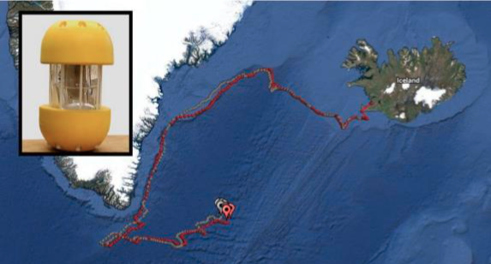
Costs
- All costs in USD
Item | Costs | Total for 5 bottles
Verkís
Bottle | 500$ | 2500
GPS transmitter | 300$ | 1500
Launch / transportation | 300$ | 1500
Other costs | 2000$ | 2000
 |  | 7500
The PAME Secretariat will look into funding opportunities.
Outreach
The PAME Website will host the map. It can be further distributed (embedded) to other websites. Snapshots will be shown frequently on PAME’s Social media accounts, and the Arctic Council website/social media.
Local media in Iceland will be sent press releases and assistance with similar efforts amongst the co-leads will be endorsed.
Finally, a video will be made when the plastic bottles have all washed ashore to show their journey.

Project video
A simple video about the project is in production as of January 2019 which will be released in early 2019. Additional video may be produced during the Icelandic Chairmanship in coordination with the Plastic Conference.

Art Marine Litter Competition
TBC. Keep Sweden Clean to be contracted to run Arctic competition. Proposal to be presented at PAME I-2019.

Marine Litter Graphics Site
Continue the work on the Arctic marine Litter graphics site on the PAME website (here )
This site currently holds numerous graphics and videos, produced by PAME and others. In addition, GRID-Arendal is in the process of developing further graphics for the Marine Litter diestop study which will be posted on this site.

