Guidelines for Implementing an Ecosystem Approach to Management of Arctic Marine Ecosystems
  - Arctic Council Joint PAME, CAFF, AMAP, SDWG Ecosystem Approach Expert Group

Table of Contents
1. Introduction 2
2. Framework for EA implementation 3
3. Guidelines for Implementing EA in the Arctic 5
General points 5
3.1 Identify the geographic extent of the ecosystem 6
3.2 Describe the biological and physical components and processes of the ecosystem including humans 8
3.3 Set ecological objectives that define sustainability of the ecosystem 8
3.4 Assess the current state of the ecosystem (Integrated Ecosystem Assessment) 9
3.5 Value the cultural, social and economic goods and services produced by the ecosystem 11
3.6 Manage human activities to sustain the ecosystem 12
4. Acknowledgements 13
Annex 1: List of acronyms 13

1. Introduction
The concept of the Ecosystem Approach to management (EA) has been around for at least 30 years and has been extensively discussed, elaborated and developed within national and international fora. The Convention on Biological Diversity adopted a Guidance for the Ecosystem Approach in 2000 at its 5th Conference of the Parties (CDB COP V/6). The EA was adopted as an overarching principle and approach by Arctic Council Ministers in 2004 as part of the Arctic Marine Strategic Plan (AMSP). In 2011, the Ministers established an expert group on Arctic ecosystem-based management (EBM), which reviewed the EA (or EBM) concept and provided a definition of EA along with principles and recommendations that were adopted as part of the Kiruna Declaration in 2013. In Iqaluit in 2015, and in Fairbanks in 2017, the Arctic Council Ministers recognized the need for EA and requested and encouraged the development of practical guidelines for EA implementation in the Arctic.
PAME established an EA Expert Group (EA-EG) in 2007 that was broadened in 2011 as a joint group with participation of three other Arctic Council working groups (AMAP, CAFF, and SDWG). The EA-EG convened six EA workshops from 2011 to 2018, and a first international EA conference in August 2016 (in Fairbanks, Alaska). The workshops addressed key aspects of implementing EA in the Arctic: setting geographical boundaries, defining a framework, assessing data issues, reviewing case studies, and setting ecological objectives. The objective of the 6th workshop was to scope and start work on development of guidelines for EA in the Arctic. The guidelines presented here are the culmination of the discussions at all of the workshops, and the participation of the scientists, managers, community leaders and representatives of Permanent Participants who attended is greatly appreciated by the Joint EA-EG. These first guidelines are developed to assist scientists, policy-makers, managers and communities in implementing an ecosystem approach for Arctic marine ecosystems.
EA in the Arctic is a potentially powerful force for coordination (e.g., management of fishing fleet diversity) and cooperation (e.g., co-management for food security such as caribou and bowhead whales). It addresses the interplay between resource extractions, resource managers, conservation agencies, and indigenous users. Humans are part of the Arctic ecosystem. The EA is about taking a holistic approach which recognizes the interlinked nature of the ecosystem. The overarching goal is to manage human activities and behavior in order to achieve or maintain sustainable use and long-term integrity of ecosystems.
The ecosystem approach includes management and conservation approaches, such as protected areas, single-species conservation programmes, and the precautionary approach, as well as other measures carried out under existing national policy and legislative frameworks. This includes the Indigenous Peoples’ concepts of conservation and overall management. The EA allows us to deal with complex situations.

Definition
Arctic Council Ministers agreed in 2013 (Kiruna Declaration) to the following definition for EA:
Comprehensive, integrated management of human activities based on best available scientific and traditional knowledge about the ecosystem and its dynamics, in order to identify and take action on influences that are critical to the health of ecosystems, thereby achieving sustainable use of ecosystem goods and services and maintenance of ecosystem integrity.
This definition has four parts: 1) it is explicit about management of human activities; 2) it is based on the best knowledge available about the ecosystem; 3) the purpose is to make appropriate and effective management decisions; and 4) the goal is to ensure sustainable use while maintaining ecosystem integrity.

2. Framework for EA implementation
The Arctic Council has developed a framework for implementation of the Ecosystem Approach to management of human activities in Arctic marine and coastal environments. The EA framework consists of six related elements:
- Identify the geographic extent of the ecosystem;
- Describe the biological and physical components and processes of the ecosystem including humans;
- Set ecological objectives that define sustainability of the ecosystem;
- Assess the current state of the ecosystem (Integrated Ecosystem Assessment):
- Value the cultural, social and economic goods produced by the ecosystem; and
- Manage human activities to sustain the ecosystem.

While they are numbered, the elements do not necessarily need to be sequential although they are eventually linked in an iterative and adaptive operational management cycle (Fig. 1). Monitoring is an essential component of EA as illustrated in the schematic representation of the framework (Fig. 1). Monitoring provides updated information of the status of ecosystem components and human activities and pressures, which is required for conducting an Integrated Ecosystem Assessment. Monitoring and assessment form in turn the basis for advice on the adaptive and responsive management measures needed to maintain or achieve the agreed ecological objective for the ecosystem. When implemented and established operationally, the EA represents an iterative cycle of monitoring, assessment, and adaptive management measures.

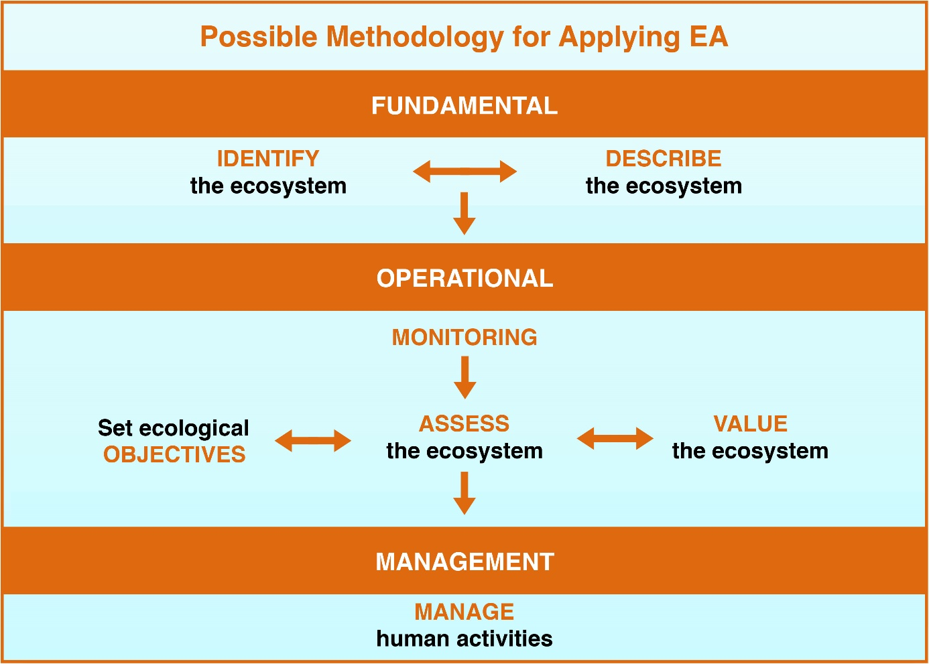
Figure 1. Framework for implementing the EA to management of marine ecosystems in the Arctic (see reference in footnote 3).

There is no single way to implement the Ecosystem Approach, as it depends on local, provincial, national, regional, and global conditions. Nevertheless, the common denominators described in these guidelines can provide a framework for delivering the objectives of the Arctic Council and its member countries.

There is a dual meaning of “management” in the context of EA. It can be understood in a narrow sense as the sixth element of the EA framework, or in a wider sense as the whole EA framework with all six elements.
The relationship between the six elements of EA and the definition of EA is illustrated in Figure 2. The EA is very much a foundation and mechanism for sustainable development, which is reflected in the dual objective of having use without compromising the integrity of the ecosystem.
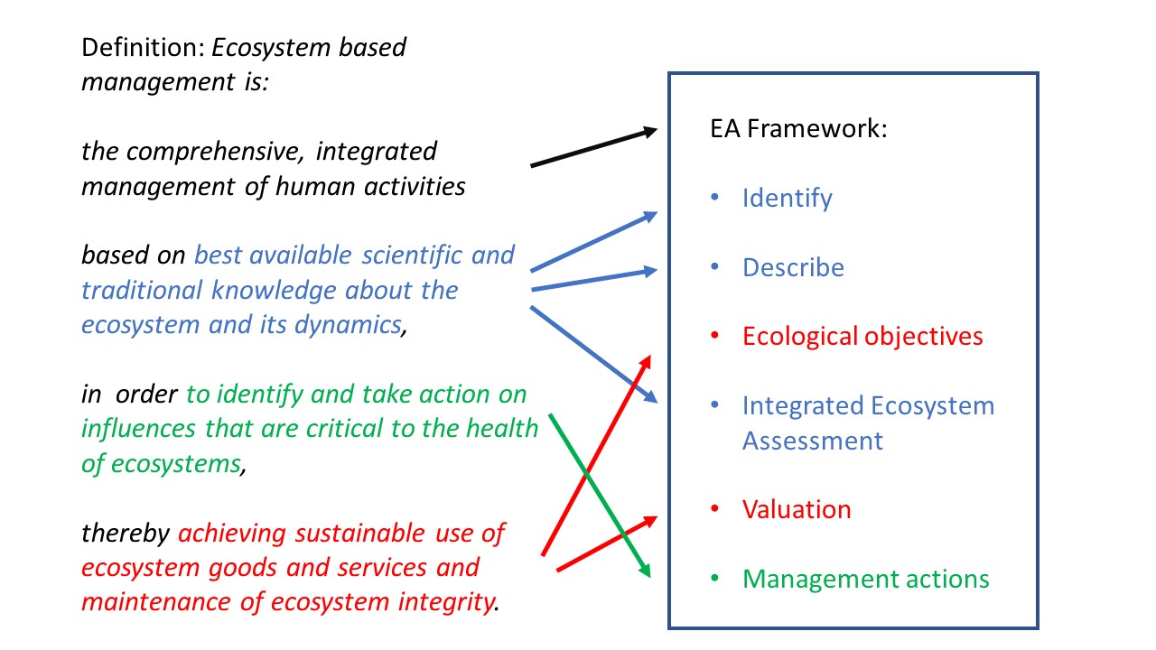
Figure 2. How the 6-element EA Framework (on the right) is related to the definition of Ecosystem Approach to management (on the left).

3. Guidelines for Implementing EA in the Arctic

General points
A strong theme in discussions at EA workshops is that Traditional and Local knowledge (TLK)/indigenous and local knowledge is important to different aspects of EA from developing guidelines to implementing the approach. Another recurring theme is the importance of communication, participation and inclusivity. EA benefits from including rightsholders and stakeholders in the different stages of the process. This includes co-production of knowledge which can provide a more comprehensive and holistic understanding of the Arctic ecosystems and the changes that are occurring. An inclusive process will help build interest, expand participation and create settings for those who live and operate in the Arctic to be part of the EA process. Communicate and engage early and often is the message from rightsholders and stakeholders in local and indigenous communities.
Implementation of EA is a dynamic and ongoing process. Setting objectives, valuing ecosystem goods and services, conducting integrated assessments and managing human activities all benefit from the iterative process of monitor, evaluate and adapt.
This first set of EA Guidelines is crafted at the Large Marine Ecosystem (LME) scale and covers the six main elements of EA. Future Guidelines may address EA activities at smaller geographical scales and provide more detailed guidence for particular elements, such as defining ecological objectives, monitoring, or valuing the ecosystem.
Following are the proposed set of guidelines to implement EA in the Arctic organized by the six elements of the EA Framework.

3.1 Identify the geographic extent of the ecosystem
The 18 LMEs in the Arctic (Fig. 3) provide a delineation and boundaries which are useful for implementation of theEA in the Arctic (reference to footnote 3). The LME boundaries define areas of coherent ecological and geophysical processes and provide an appropriate scale for assessing the structural and functional integrity of ecosystems, including the separate and cumulative impacts of human activities.
While LMEs can be a useful scale for the EA to management, integration across scales is an important consideration and should be done in an orderly fashion, while retaining focus on the integrity of the ecosystem. For example, ecosystem features important to Arctic communities may occur at scales smaller than LME, such as areas for whaling and fishing. Pan-Arctic oceanographic processes and fluxes of water and organisms across LME boundaries (e.g. seasonal migrations of birds and mammals) mean that scales larger than the LME, or connectivity between different LME´s, also should be taken into consideration.
Many of the Arctic LMEs are cross-boundary, including waters under the national jurisdiction of two or more Arctic states. Some of them also contain areas beyond national jurisdiction, e.g. in the Bering Sea, the Norwegian Sea, and most notably in the Central Arctic Ocean which includes a large area of High Seas (reference to footnote 3). Consideration of the transboundary nature of LMEs, as well as interactions between adjacent LMEs (e.g. migrations of birds and mammals), require cooperation between Arctic states and organizations with jurisdiction and management competence within a given LME.

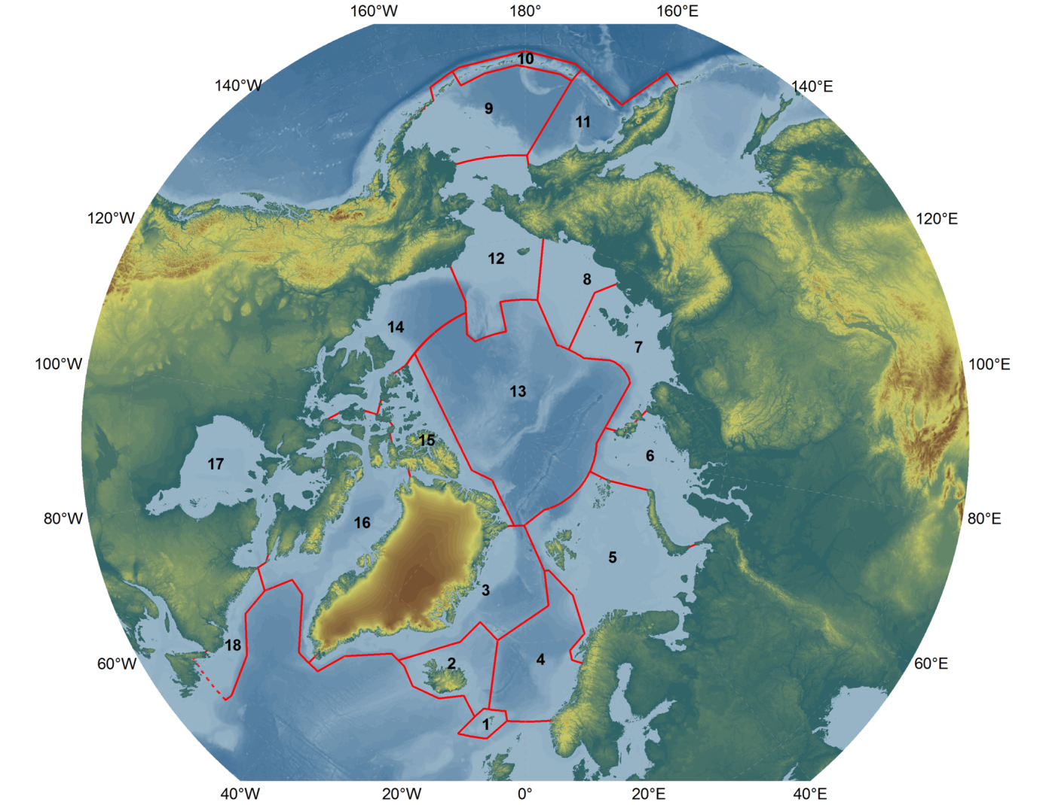
Figure 3. The 18 Large Marine Ecosystems: 1 – Faroe Plateau, 2 – Iceland Shelf and Sea, 3 – Greenland Sea, 4 – Norwegian Sea, 5 – Barents Sea, 6 – Kara Sea, 7 – Laptev Sea, 8 – East Siberian Sea, 9 – East Bering Sea, 10 – Aleutian Islands, 11 – West Bering Sea, 12 – Northern Bering-Chukchi Seas, 13 – Central Arctic Ocean, 14 – Beaufort Sea, 15 – Canadian High Arctic-North Greenland, 16 – Canadian Eastern Arctic-West Greenland, 17 – Hudson Bay Complex, 18 – Labrador-Newfoundland.

3.2 Describe the biological and physical components and processes of the ecosystem including humans
Knowing what is critical to the health of an ecosystem and how to evaluate the integrity of the ecosystem rest on a fundament of ecosystem understanding. How well do we know how a given LME is organized, and how does it work? The focus should be on describing the key characteristics of an ecosystem, which is crucial for understanding an ecosystem with its underwater landscape, ocean currents, and drifting, resident, and migratory biota ranging from viruses and bacteria to marine mammals. How are all these parts connected into a functional unit?
A description of the ecosystem can be achieved or supported through construction of conceptual models. This description of the ecosystem should encompass human activities (including cultural and social elements) along with the natural (non-human) components and processes of the system. It is recommended that development of these conceptual models be done in close collaboration with Indigenous Peoples and relevant stakeholders, using Indigenous and local knowledge along with knowledge from physical, biological and social sciences. The descriptive element of EA should also include identification of current or future threats and pressures to all components of the ecosystem. Prioritizing threats and pressures can stimulate interest and participation by stakeholders and is another opportunity for building partnerships.
There are spatial and temporal components to the description of the ecosystem. This should include identification of hot-spots of productivity, high biodiversity areas, and other ecologically-significant areas, as well as descriptions of migratory patterns and habitats used by fish, birds, and mammals during life cycles and their annual migrations. In addition, a description of where important areas and habitats overlap with human activities (e.g., shipping, and subsistence use) should be included. In terms of the temporal component, this should describe dynamics through time (at seasonal, interannual and longer time scales) of ecosystem components, pressures, activities, and scenarios of future ecosystem states. It is also important to adopt procedures for regular updates of information on ecosystem components and pressures. When building the conceptual model, it will be useful to imagine plausible futures of the social-ecological system.
Many of the areas in the Arctic are data deficient when it comes to describing the ecosystem. This causes a problem when using models that require an abundance of data and is also an issue in identifying hot spots of productivity, biodiversity, etc. For data deficient areas the method used to assess the information should consider the quality and quantity of data available. This will also result in the identification of data gaps which is an important deliverable in and of itself.

3.3 Set ecological objectives that define sustainability of the ecosystem
As for the EA in general, it is important to adopt a collaborative and participatory approach when developing objectives. Setting ecological objectives is in essence striking a balance between human use and conservation of ecosystems to achieve sustainability. The objectives of nations and managers should take into account the needs and objectives of Indigenous and local communities, and in this way the top-down approach can be balanced with a bottom-up approach. Developing objectives will entail identifying key concerns (e.g., drivers of change, governance gaps, and fluctuation in, or thresholds of ecosystem services) and measurable variables in order to take action when needed.
A full range of ecological objectives could include (but not be limited to): harvested living resources, endangered species, well-being of animals, habitats, water quality etc. The ecological objectives should reflect ecological features on one hand and be related to the impacts of human activities on the other. To be operational, ecological objectives may have to be linked to, or translated into, management objectives. An example from fisheries management is the objective to keep exploited fish populations above minimum stock levels, which is then translated into a system of fish quotas that are the operational management objectives. There may also be important social and cultural objectives linked to ecological objectives (e.g., conservation of ringed seals for umiaq (skin-boat) building to enable whale hunting). Ecological objectives will have a spatial component in ecosystems where sustainability entails ensuring future functioning of vulnerable places, hotspots of productivity, Vulnerable Marine Ecosystems (VMEs), etc.
The issue of scale integration comes into play with regard to setting ecological objectives. Thus, objectives for local habitats, such as spawning or nursery areas for fish, or breeding colonies for seabirds, serve objectives to maintain healthy populations and ensure their functional roles in the wider ecosystem at a larger scale. Setting ecological objectives from a holistic perspective at the LME scale is a way to ensure that the sum of management decisions at smaller scale, e.g. at municipality or community level, do not impair the functional integrity of the larger ecosystem.

3.4 Assess the current state of the ecosystem (Integrated Ecosystem Assessment)
Assessment of ecosystem status is a core element of the EA which sets it apart from previous sector-based management approaches. The focus is on the state of the ecosystem, which needs to be assessed with due regard to its dynamic nature. Integrated Ecosystem Assessment (IEA) is an assessment of the status and trends in all relevant ecosystem components and thereby of the overall state of the ecosystem. It includes assessments of the impacts by various human activities such as fishing, pollution, and coastal development, as well as the overall or cumulative impacts caused by those activities. Integrated assessments also include socioeconomic factors and conditions, e.g. as driving forces for use and environmental impacts, and as consequences back for society of altered provision of ecosystem goods and services.
Marine ecosystems are inherently dynamic and ever changing. Physical forcing, expressed by variability in ocean climate (currents, water masses etc.), has large influences on populations of fish and other organisms and on ecological processes. These processes include trophic interactions such as predator-prey relationships and food-web dynamics. There is, therefore, an intricate relationship between physical forcing and biological interactions in marine ecosystems with simultaneous and linked bottom-up and top-down regulating factors of ecological processes. The strengths of these regulating factors may fluctuate, reflecting time delays by mechanisms such as strong year-classes of fish caused by climatic conditions in one period, being manifested as ecological interactions some years later when the fish grow up.
The large natural variability of marine ecosystems poses a challenge when it comes to assessing the impact of human activities, both individually and cumulatively. The impacts or effects e.g. from fishing or pollution, come in addition to the natural fluctuations in ecosystem components and may be difficult to distinguish from the natural variations. Assessments therefore need to be careful and thorough in order to allow effects from human activities to be distinguished from the natural fluctuations of ecosystem components such as fish stocks. This is challenging but not impossible; it requires the best use of the best available scientific and indigenous and local knowledge.
An IEA builds on two main pillars: 1) updated information from monitoring of ecosystem components and human activities, and 2) ecosystem understanding, accumulated from past and on-going research, as well as being a by-product from assessment activities themselves. Assessment and monitoring need to go hand-in-hand. IEA is not possible without monitoring; it depends on comprehensive monitoring to supply the necessary information to assess the changing state of an LME. Therefore, a coordinated monitoring and assessment program is essential to ensure that relevant information is collected for an IEA. Monitoring of an LME should include climate, physical oceanography, nutrients, contaminants, plankton, benthos, fish, birds, and mammals, as well as human activities e.g. in fisheries, shipping, and other sectors. The state of monitoring varies among Arctic LMEs, but in most cases, information is being collected by a multitude of national government and regional agencies, communities, and industries, as well as by internationally coordinated programs. A key step is to make an inventory and bring together all relevant existing information from monitoring for use in IEAs for a given LME. Such an exercise may reveal gaps which may have to be filled, but also possible redundancies and scope for more cost-effective monitoring through coordination and cooperation.
Assessment can be an important component of co-management, where both Indigenous/Traditional and Local Knowledge (TLK) and scientific knowledge can contribute. Examples of co-management include the Inuvialuit-Inupiat Beluga Whaling Commission (IIBWC) and the Inuvialuit-Inupiat Polar Bear Commission (IIPBC). In the North Slope Borough of Alaska in the United States, communities drive the science and monitoring which provides a good opportunity to implement EA. IEA can also contribute substantially to federal management documents such as the U.S. National Environmental Policy Act (NEPA) assessments and consultations. To maximize stakeholder engagement, the process of constructing an IEA should be open and inclusive.
There is a diversity of approaches to IEA. Some aspects are shared or common, and some are specific to a program or project (Table 1). There is still much to be gained by “learning by doing”. The International Council for Exploration of the Sea (ICES) is doing this on an extensive scale through working groups conducting IEAs for regional ecosystems in the North Atlantic, including two Arctic LMEs (the Barents and Norwegian seas), as well as the central Arctic Ocean (jointly with PICES and PAME). At the 6th EA Workshop, an iterative process was suggested whereby best practices are identified from present knowledge, and then updated as we gain more experience.
Table 1. Elements of Integrated Ecosystem Assessments used commonly or more variably across assessment activities.
Common elements:
- Use of trend analysis of multivariate datasets to describe and evaluate recent and ongoing changes in the ecosystem as a whole
- Conceptual models as organizing and communication tools
- Human dimension; socio-economic information, indigenous and local knowledge
- LME scale
- Monitoring and evaluation (adaptive management)
Other elements:
- Risk Assessment, including ecological, economic, social and management risks
- Analysis of outcomes and trade-offs of alternative management scenarios (management strategy evaluations)
- Indicators with target levels
- Qualitative descriptors with associated criteria and indicators
- Sub-LME scale
- Gap analysis

The purpose of conducting an IEA is to inform management decisions (element no. 6 below). There is a need for an advisory mechanism that can translate the findings about the complexity of an ecosystem as revealed by an IEA into clear options for management measures. This applies to harvest of living resources by commercial fisheries and subsistence harvest, as well as conservation measures to protect species and habitats to ensure good ‘health’ and overall ecosystem integrity . The advice to managers should be in relation to the agreed ecological objectives set for the specific ecosystem.
The advisory mechanism should be institutionalized as part of the overall EA management system. It is important that the advice is trusted as representing the best available knowledge about the ecosystem and its dynamics. There will often be tension between industrial developments and conservation in order to maintain the integrity of the ecosystem – basically where is the upper limit of sustainable use. Deciding this is complicated by large natural variability and the additional changes Arctic ecosystems now experience due to climate change. The responsibility for giving management advice based on IEA needs to be clearly identified, and the integrity of the advisory process needs to be protected from conflicts of interest.
Box - Assessment products from work in the Arctic Council
The Arctic Council working groups carry out assessments as part of their work plans. Assessments of environmental conditions and status of biodiversity in Arctic ecosystems are done primarily by the Arctic Monitoring and Assessment Programme (AMAP) and the Conservation of Arctic Flora and Fauna (CAFF) working groups. The Protection of the Arctic Marine Environment (PAME) working group and the Sustainable Development Working Group (SDWG) carry out assessments with focus on human activities and conditions for people living in the Arctic.
Below is a short list of major recent assessments by Arctic Council working groups. These reports, and many others, can be found at the web pages of the working groups.
AMAP
- AMAP Assessment 2018: Biological Effects of Contaminants on Arctic Wildlife and Fish
- Snow, Water, Ice and Permafrost in the Arctic (SWIPA) 2017
- Adaptation Actions for a Changing Arctic: Perspectives from the Baffin Bay/Davis Strait Region
- Adaptation Actions for a Changing Arctic: Perspectives from the Bering-Chukchi-Beaufort Region
- Adaptation Actions for a Changing Arctic: Perspectives from the Barents Area.
CAFF
- Arctic Biodiversity Assessment 2013
- State of the Arctic Marine Biodiversity Report
PAME
- Arctic Marine Shipping Assessment 2009 Report
- Arctic Ocean Review Final Report (2013)
SDWG
- Arctic Human Development Report 2 (2015)
- Adaptation Actions for a Changing Arctic (2013)

3.5 Value the cultural, social and economic goods and services produced by the ecosystem
The Arctic Council Conservation of Flora and Fauna (CAFF) working group has conducted (with UNEP and WWF) a scoping study on Arctic ecosystem services and values using the Economics of Ecosystems and Biodiversity (TEEB) approach and methodology. TEEB is a global initiative coordinated by UNEP that draws attention to the benefits that people gain from nature (ecosystem services), and to the costs to society when ecosystems are damaged. TEEB provides an analytical approach, tools and guidance that can help make the range of nature’s benefits more visible to stakeholders and managers. The scoping study contains key findings from compiling and synthesized information, issues, current practices, methodologies and perspectives on Arctic ecosystem services and their values in relation to decision making. The study also lists and discusses policy areas for potential follow up using the TEEB approach and described option for next steps.
One of the key findings of the CAFF scoping study (Key Finding 6.1) is that “Engagement of Arctic Indigenous organizations and a broad range of stakeholders in participatory development of knowledge and policy alternatives is central to a successful TEEB Arctic study”. As with setting ecological objectives, it is important to include Indigenous Peoples and local communities in the process of valuation. For successful community buy-in, the valuation process needs to be transparent. One method that has proven to be effective is the development of conceptual models by the community to describe their needs from ecosystem resources. These can be Qualitative Network Models QNM or a set of ratings or ranks applied to the “goods”.

“Value” can have a monetary implication, but non-monetary values are important as well. The CAFF scoping study emphasizes this point by explaining that the TEEB approach does not limit the valuation of ecosystem services to economic instruments (Key Finding 3.3). Social, cultural and other non-monetary values are incorporated into some management approaches already and provide guidance for implementing EA in the Arctic. For example, maintaining the economic and social integrity of communities is an explicit value in the U.S. National Standards of the Magnuson-Stevens Act under the “principles that must be followed in any fishery management plan to ensure sustainable and responsible fishery management”. Food security is a value of particular importance to communities that rely on subsistence harvest of whales, other marine mammals, birds, and fish.
There are quantitative methods for assessing the non-market value of ecosystem goods and services. Some Arctic ecosystem goods and services, like seafood, are traded in explicit markets where signals about their economic value are conveyed by prices at which they are bought and sold. However, not all ecosystem goods and services are traded in explicit markets. For these non-market ecosystem goods and services, quantitative methods developed in the environmental economics literature can be utilized to measure values. These non-market valuation approaches fall into two main types that differ in the type of data used to infer values. Revealed preference methods use information on observed behavior to infer values, while stated preference methods use carefully worded survey questions that elicit information used to infer economic values. One consideration is whether one should attempt to conduct valuation of a resource that is irreplaceable or to changes that are irreversible, in this case the resource may not have zero value but rather infinite value. Perhaps some features or aspects of the ecosystem will be defined as non-negotiable (e.g., because it contributes to an essential part of human culture or way of life), such as subsistence needs. One of the key findings (Key Finding 3.8) of the CAFF scoping study is that taking an interdisciplinary approach that combines economic and sociocultural analyses to the benefits people receive from Arctic ecosystems offers a complementary approach to communicate to decision makers the importance of nature to people, and a toolkit for evaluating policy options and integrating stewardship into decisions.
The task of valuing ecosystem services can be quite large. One strategy could be to identify key ecosystem goods and services that are likely to hold large values (monetary, societal, or otherwise) and focus on those. For example, the CAFF scoping study summarizes input from experts on what ecosystem services are important and the perceived risks to those services. The study also emphasizes that ecosystem services work should take a holistic approach because no one service can be treated as a separate, unconnected entity (Key Finding 2.2). Another strategy could focus on key goods and services that affect management decisions. However valuing is implemented, the rapid pace of current and anticipated future changes in the Arctic means that ecosystem values should have a dynamic component. The valuation needs to account for changes in social, economic and political systems and to anticipate future changes in and uses of the ecosystem. Furthermore, the CAFF scoping study Key Finding 2.6 states that “Arctic environmental conditions are associated with potential for rapid changes in ecosystem services and high uncertainty – providing strong incentive to include ecosystem services in policy”.

3.6 Manage human activities to sustain the ecosystem
Management decisions and measures need to be responsive and adaptive to the changing conditions in an ecosystem as well as in those societies that depend on the ecosystem. Adaptive management involves coordination between agencies, sectors, regulations and conventions. It entails evaluation of the progress of management with regular review, addressing in consultation with stakeholders the following types of questions: Is the management successful? Are objectives achieved?
Building on the theme of incorporating Indigenous and local communities’ objectives and values, management should be flexible in order to align with the opportunistic nature of maintaining food security. Given a dynamic and warming Arctic, management should be designed to respond to changes in the natural non-human system. Responding to advice based on updated information on the changes that are taking place in the ecosystem as documented in IEAs, will allow adaptive adjustment of management decisions and actions, in line with the agreed ecological objectives. For example, time-limited area closures in fisheries management can be implemented in response to changes in the abundance and distribution of fish stocks with climate change. This is just one example, and other actions can be taken to allow flexibility in shifting access from one resource to another based on ecosystem changes or societal needs. Educating the managers on the importance of EA may assist with identifying optimal ways to achieve adaptive management goals (i.e. briefing fishery management councils on the need for time-limited area closures as they help meet larger objectives shared by both managers and fishers).
To achieve successful management within the context of EA, it is important to understand what the available management tools are and what the management entities can do. In addition, given the need for scale integration and transboundary management, coordination and communication among management organizations should be encouraged. The different groups should work together to identify over-arching goals.
Communication is an important part of successful management. Managers should provide the public with information, and they should also gather public feedback. The ultimate goal is to encourage a transparent, dynamic, and iterative management process.
Prepared by:
Elizabeth Logerwell, Alaska Fisheries Science Center, National Marine Fisheries Service, NOAA, USA
Hein Rune Skjoldal, Institute of Marine Research, Norway

4. Acknowledgements
The authors gratefully acknowledge the contribution of the participants of the 6th EA workshop held 9-11 January 2018 in Seattle, USA (https://pame.is/images/03_Projects/EA/6th_Workshop/6th_EA_Workshop_Report.pdf). In addition, Leah Brown, Catherine Coon, Eva Degré, Anja Elisenberg, Jon L. Fuglestad, Marthe Margrethe Haugan, Marianne Kroglund, Hanne-Grete Nilsen, Rebecca Shuford, and Cecilie von Quillfeldt provided many helpful suggestions to earlier drafts of the Guidelines.

Annex 1: List of acronyms

AACA | Adaptation Actions for a Changing Arctic
AMAP | Arctic Monitoring and Assessment Programme
AOA | Arctic Ocean Acidification
CAFF | Conservation of Arctic Flora and Fauna
EA | Ecosystem Approach
EA-EG | Ecosystem Approach Expert Group
EBM | Ecosystem-Based Management
ICES | International Council for the Exploration of the Sea
ICG-COBAM | OSPAR Commission's Intersessional Correspondence Group on Coordinated Biodiversity Assessment and Monitoring
IEA | Integrated Ecosystem Assessment
IIBWC | Inuit-Inuvialuit Beluga Whaling Commission
IIPBC | Inuit-Inuvialuit Polar Bear Commission
IPCC | Intergovernmental Panel on Climate Change
LME | Large Marine Ecosystems
TLK | Traditional and Local Knowledge
UNFCC | United Nations Framework Convention on Climate Change
NOAA | National Oceanic and Atmospheric Administration
PAME | Protection of the Arctic Marine Environment
QNM | Qualitative Network Model
SAMBR | State of the Arctic Marine Biodiversity Report
SDG | Sustainable Development Goals
SDWG | Sustainable Development Working Group
SWIPA | Snow, Water, Ice, and Permafrost in the Arctic
VME | Valuable Marine Ecosystem
WGIBAR | Working Group on the Integrated Assessments of the Barents Sea
WGICA | Working Group on Integrated Ecosystem Assessment (IEA) for the Central Arctic Ocean
WGINOR | Working Group on the Integrated Assessments of the Norwegian Sea

https://www.cbd.int/decision/cop/default.shtml?id=7148
EA and EBM are synonymous terms for the same management concept.
https://pame.is/images/03_Projects/EA/EA_Docs_and_Workshop_Reports/Status_reports/Status_of_Implementation_of_the_Ecosystem_Approach_to_Management_in_the_Arctic.pdf
Article 2 United Nations Convention on Biodiversity (https://www.cbd.int/convention/text)
The Sitka Workshop is a good example (Marysia Szymkowiak pers. com)
Harvey, C.J., Reum, J.C.P., Poe, M.R., Williams, G.D., and Kim, S.J. 2016. Using Conceptual Models and Qualitative Network Models to Advance Integrative Assessments of Marine Ecosystems. Coast. Manag. 44(5): 486–503. Taylor & Francis. doi:10.1080/08920753.2016.1208881.
https://www.fisheries.noaa.gov/national/laws-and-policies/national-standard-guidelines
Champ, P.A., K. Boyle, and T.C. Brown (2017) A Primer on Nonmarket Valuation. Springer Netherlands. Freeman A.M., J.A. Herriges, and C.L. Kling (2014) The Measurement of Environmental and Resource Values: Theory and Methods. New York: Taylor & Francis.

