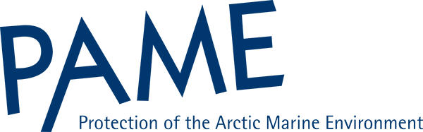
Meaningful Engagement of Indigenous Peoples and Local Communities in Marine Activities

Part II Report
Summary for Policy Makers

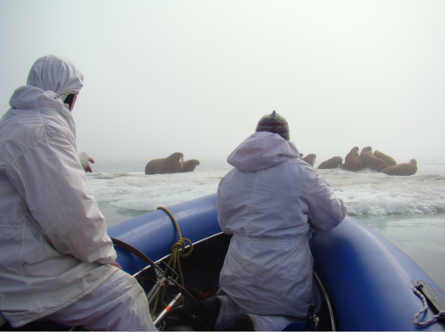
December 21, 2018
Summary for Policy Makers

Introduction
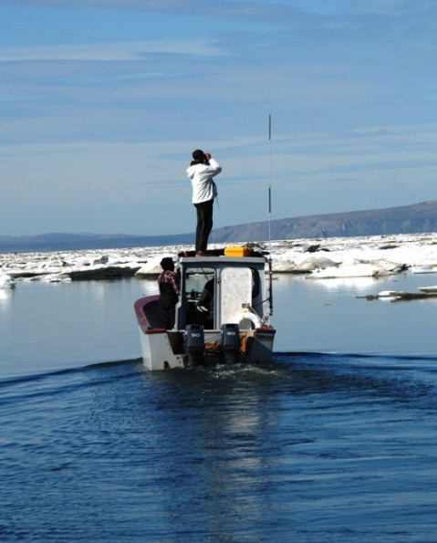
Indigenous Peoples and local communities located in Arctic coastal areas depend on the sea for food, transportation, for cultural and spiritual identity and social well-being. Industrial activities, marine management regimes, scientific research, shipping, emergency response, and tourism in Arctic marine and coastal areas can impact these people. It is vital that they are involved and meaningfully engaged in such activities and involved in mitigating possible negative consequences. The Arctic Council has provided recommendations and guidance on how government and industry can engage Indigenous Peoples and local communities. In addition, local communities, indigenous organizations, industry, and governments have also provided guidance and rules. However, these are spread across Arctic Council working groups, various sectors, reports, governments and other documents, and present a variety of perspectives.

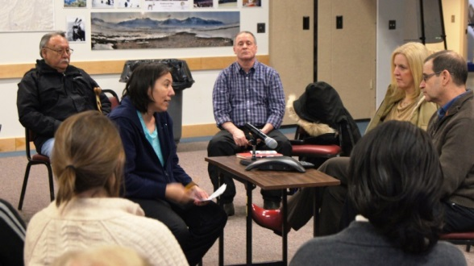
This report has compiled hundreds of documents related to engagement of Indigenous Peoples and local communities and looked at them by source (Artic Council, Indigenous Peoples and local communities, governments, industry, and academia/NGO’s) and sector (scientific research, shipping, marine management, resource exploration and development, tourism, and emergency prevention, preparedness, and response). Examination of existing information on requirements, guidance or recommendations for engagement can help identify approaches, processes, and mechanisms for achieving meaningful engagement.

The reader is encouraged to read the summary of the analyses in the MEMA II report, as well as the complete analyses of engagement documents and the information database on the web page at____.

The audience for this Arctic Council report is the Arctic Council itself, governments, Indigenous Peoples and local communities, industry, NGOs, and academics. The intent of this report is to inform on ways to improve relationships and interactions with Indigenous Peoples and local communities who are most affected by maritime decisions, actions and activities.

What is Meaningful Engagement?

The term “meaningful engagement” has no single definition and does not have a “one size fits all” approach for all activities. It is understood to include a range of practices by government, industry and other actors seeking to operate in the Arctic region. What is considered meaningful engagement can be a matter of perspective by different entities.

An engagement approach can be considered meaningful if it achieves the purposes for which the engagement is initiated. Determining the purposes of engagement in partnership with Indigenous People and local communities prior to the engagement facilitates the engagement process. It is important that both sides – those engaging and those being engaged – feel that engagement has been meaningful.

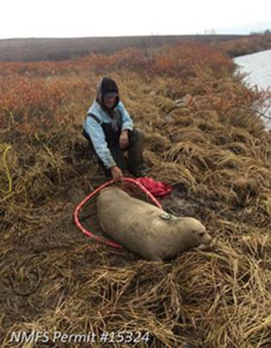
Meaningful engagement can be shown by respect for culture and values and the inclusion of Indigenous or local knowledge. What is needed for meaningful engagement to be achieved is based on various factors such as the actors being engaged; culture, temporal and spatial scales of the project; and communities impacted, the location of communities, and the nature of a proposed activity.

Ultimately what constitutes meaningful engagement is determined by the Indigenous communities that are being engaged.

Meaningful engagement can also be understood as a requirement or obligation to be fulfilled as part of a project or activity when legislation, treaties, land claim agreements, or other regulations in Arctic countries place an obligation on its government to engage with Indigenous People and local communities. Such engagement may be related to government-to-government engagement including consultation, as well as the right of indigenous peoples to participate in decision-making that may affect them, and the right to self-government. These laws, treaties, land claim agreements, or other regulations, may place minimum requirements on governments to engage.

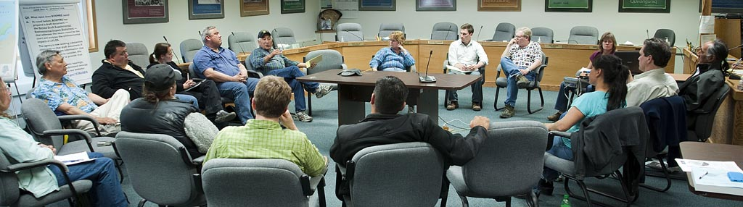
Meaningful engagement does not begin when a problem occurs, it is an ongoing process that builds a foundation on which problems can be solved or managed. Be proactive by engaging with stakeholders in their community and near the site where the activity will occur. A key element to the pre-consultation phase is involving Indigenous communities in decisions about how engagement will occur and determining which issues will be on the agenda.

Ongoing communication is often recognized as contributing to meaningful engagement. For instance, tribes in the Bering Strait region have described meaningful engagement as, “an ongoing and meaningful relationship between tribes and a federal agency that has the mutual objective of collaboration and should not be issue-based, it should be a relationship that is maintained even where no major issues of contention arise”.

Although approaches to engagement with Indigenous Peoples and local communities in the Arctic will vary depending on the context and parties involved, building trust, a clear delineation of expectations, incorporating Indigenous Knowledge and local knowledge, and ongoing communication between actors can lead to meaningful engagement. The underlying concepts and foundations for meaningful engagement will be the same across contexts, but the approaches taken will depend on the actors involved. Current approaches have identified meaningful practices to engagement and can be used to improve future efforts and establish ongoing relationships with Arctic Indigenous Peoples and local communities.

Good Practices

A review of the approaches to engagement utilized for this project have highlighted practices that governments, industry sectors, and other actors are currently using to engage with Indigenous Peoples and local communities. These approaches have been used to determine good practices outlined below. Many of these practices are basic and appear across sources and sectors, others are not as widely identified. These are characterized as “good practices” because the report has not defined “best practices” and although many of these are probably best practice, it may change or become more refined with time.

Good practices for meaningful engagement can be applied within any sector or activity to meet the context of the situation. Also, these practices are applicable to onshore as well are marine activities.

Summary of Good Practices for Meaningful Engagement
- Identify the issues and factors needing engagement which benefit from engagement strategies.
- Identify potentially affected participants [and those with whom to engage]
- Consider legal obligations relevant to engagement [, if applicable].
- Consider cultural differences, location of community, and resources available.
- Develop relationships between actors and Indigenous peoples based on trust and respect, with interactions to be conducted in a transparent and culturally appropriate manner.
- Identify the appropriate time to begin any engagement and the processes of engagement over the lifetime of an activity.
- Employ mechanisms for engagement by use of multiple approaches/tools and early and proactive engagement at all level
- Identify how best to communicate with Indigenous peoples and local communities.

Develop an engagement plan or agreement with the community, and report back on progress.
- Establish supportive measures including record keeping, review of processes, and dispute resolution mechanisms, as appropriate.

Lessons Learned
In addition to identifying good practices, the MEMA report found some additional guidance that can be characterized as lessons learned. Making mistakes trying to practice meaningful engagement should be considered a learning process. Some key lessons learned from this project can be summarized as follows:
Lessons Learned
General
- There is no single approach to meaningful engagement; it is a contextual process.
- Consider outlining what is meant by a meaningful role for all actors.
- Ensure that Indigenous Peoples and local communities are well informed and aware of their rights and opportunities to be meaningfully engaged.
Relationship Development
- Understanding communities and indigenous culture, heritage and traditions is necessary for meaningful for engagement.
- Relationship building and engagement should be ongoing in order to be meaningful.
- Collaboration and coordination among partners, including those that do not normally communicate directly with one another, builds relationships and communication.
- Developing capacity in communities through the provision of education, training, infrastructure, and funding, when available, facilitates engagement.
- Efforts should be taken to incorporate and apply Indigenous Knowledge and local knowledge through engagement approaches.
- Develop a foundation of trust that create clarity, certainty, and reliability through constructive dialogue and by including time for events and activities not directly related to issues.
Process
- Planning for engagement while being flexible with the process can lead to outcomes that are more fruitful.
- Aim for an engagement process that balances interests and provides for positive outcomes for all partners.
- Aim for representation on advisory councils and decision-making boards.

Next Steps
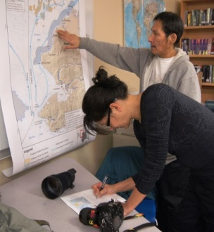
The review of recommendations and guidance by the Arctic Council reveals that it has made a range of statements and recommendations on t meaningful engagement of Indigenous Peoples and local communities, and for the involvement of Permanent Participants. However, these recommendations and guidance are found within many documents and present a variety of perspectives.

Further, the review of documents from sources outside of the Arctic Council identifies certain practices or elements of meaningful engagement with Indigenous Peoples and local communities that the Arctic Council may find useful in its work. The Arctic Council could be a forum for discussions on good engagement practices.

This report and the supporting documents can provide the Arctic Council with a value-added resource for engagement of Indigenous Peoples and local communities in their projects.

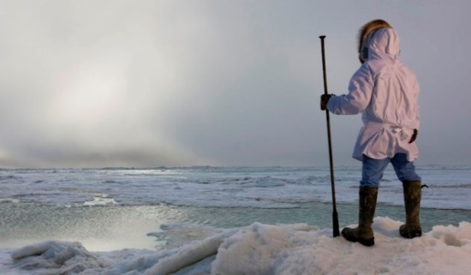
Building on this report, the Arctic Council working groups could consider developing recommendations for effective engagement, such as the SDWG Recommendations for the Integration of Traditional and Local Knowledge into the Work of the Arctic Council. The Arctic Council could consider current good practices of engagement and develop a reference guide or handbook such as the CAFF Community-Based Monitoring Handbook--Lessons from the Arctic and Beyond. Whatever the response to this report, it marks an important window of opportunity to follow on with guidance applicable to all working groups and task forces.

Background Information

Meaningful Engagement of Indigenous Peoples and Local Communities in Marine Activities, Part II Report: Findings for Policy Makers, Protection of the Arctic Marine Environment Working Group of the Arctic Council, 2019.

MEMA Informational Database with over 700 entries (located online at _______).

Meaningful Engagement of Indigenous Peoples and Local Communities in Marine Activities Information Database Analysis Phase I Narrative Summary. Elizabeth Edmondson, Dalhousie University Halifax, Nova Scotia, October 2016, Prepared for the Protection of the Arctic Marine Environment Working Group of the Arctic Council (located online at _______).

Meaningful Engagement of Indigenous Peoples and Local Communities in Marine Activities: Phase 2 Analysis--Report to the PAME Working Group of the Arctic Council. Brendan Boyd, Jessie Arthur, and Jennifer Winter, School of Public Policy, University of Calgary March 2018 (located online at _______).

Meaningful Engagement of Indigenous Peoples and Communities in Marine Activities (MEMA) – Workshop Report, Elizabeth Edmondson, September 17, 2016, Bowdoin College, Brunswick, Maine (located online at _______).

Meaningful Engagement of Indigenous Peoples and Local Communities in Marine Activities Part I Report – Arctic Council and Indigenous Engagement: A Review. Protection of the Arctic Marine Environment Working Group of the Arctic Council May, 2017 (located online at _______).

International Finance Corporation, 2007. Stakeholder Engagement: A Good Practice Handbook for Companies Doing Business in Emerging Markets
National Association of Tribal Historic Preservation Officers (NATHPO), 2005. Tribal Consultation Best Practices in Historic Preservation

