# PAME I-2018 Agenda Item x.x

**Accidents and incidents in the Arctic**

**Background**

The Arctic Marine Shipping Assessment 2009 Report contains data on shipping incidents which are more than 10 years old. Due to changes and development, including shipping traffic, in the Arctic region, there is a need for updated information on shipping incidents. A joint PAME/EPPR initiative has therefore been taken to develop a compendium of Arctic ship accidents.

PAME II-2017 adopted the following record of decision:

*PAME invites all members to submit by 1 December**any available information on ship accidents in the Arctic since 2005, taking into account the project parameters and elements contained in Appendix I to the paper titled “Compendium of Arctic Ship Accidents (CASA)” (PAME (II)/17/5.7/B) submitted by the USA.*

**Data collection and results**

The Norwegian Maritime Authority (NMA) collects accident data from Norwegian ships, and from foreign ships in Norwegian waters. All Norwegian flagged vessels are required by law to report accidents to the NMA. The reporting requirements also apply to foreign-flagged vessels when an accident occur in Norwegian territorial waters. Further details on reporting requirements can be found at www.sjofartsdir.no/en/safety/reporting-of-marine-casualtiesand-

occupational-injuries/.

We have extracted a set of incidents from our accident database, based upon the delimitation of the Arctic used in the Polar Code. Our extraction tool, however, does not support drawing of the delimitation based on exact positions. Hence, this represents an uncertainty. In the period from 2007 until November 2017 a total of 31 accidents and 10 near-miss accidents have been reported.

Figure 1 presents incidents reported to our database from 2007 until 14 November 2017. The extracted incidents are those which pose a risk to the ship or to the environment. Occupational and medical incidents are not included.

In Table 1 a summary of information on the reported incidents/accidents has been given. Detailed information is given in appendix 1.

Figure 2 shows incidents/accident per year and figure 3 presents distributed by ship categories.

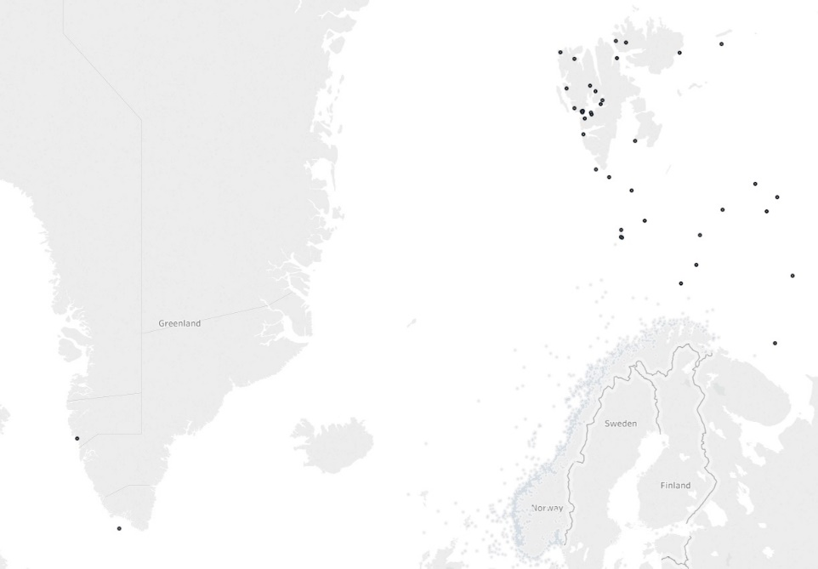

Figure 1. Incidents representing a risk to the ship or to the environment reported to NMA´s accident database from 2007 until November 2017.

Table 1. A summary of information on the reported incidents.



Figure 2. Accidents and near-miss accidents per year.

Figure 3. Accidents and near-miss accidents distributed by ship categories.